Cotto d'Este Celebrates the Understated Power of Curves

The brand explores a softer, more sinuous design language, where ceramic surfaces complement flowing volumes and sophisticated atmospheres.

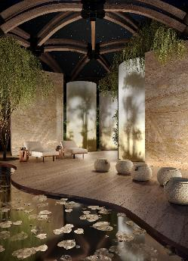
Wood Plank Ortisei Natural-9mm- Starlight Dorado glamour Glossy-3mm

In contemporary interior design, soft lines are increasingly defining spaces, sensations and atmospheres. From softly curved walls to furnishings that appear sculpted in a single gesture, the curve trend is no longer a mere stylistic choice; it is a design philosophy rooted in visual comfort and warmth, transforming environments into flowing spaces that connect with the people who inhabit them.
Cotto d'Este offers cutting-edge solutions for interpreting sinuous forms without compromise. Ultra-thin KERLITE slabs, in particular, become creative tools for architects and designers, capable of following fluid geometries and bringing character to every space. The surface itself becomes the focal point: welcoming, technologically advanced and versatile. It blends seamlessly with furnishings and volumes, creating spaces where geometric precision meets softness.

The Advantage, Arketipo and Starlight collections perfectly embody this vision, with textures that capture light and emphasise curves, and the ability to combine materials and forms in hybrid solutions that make every project unique. These collections are now joined by Legend, the new line previewed at Coverings 2026, which draws on the geological heritage of raw matter and reinterprets it for the contemporary world in its most essential form.
As personalisation and well-being become indispensable values, Cotto d'Este reaffirms its position as a leader in modern design, offering surfaces that reinvent spatial perception through visual softness and high-level technical performance.

Legend
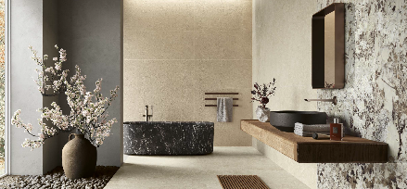
CDE-legend-primalwhite-natural-9mm-soft-6.5mm-aurabeige-blazed-9mm-allure-alaska-glossy-6.5mm-bathroom-002

Legend does not simply cover a space — it becomes its generative principle. Every slab reinterprets the sedimentary complexity of Pierre Bleue, the Belgian stone that directly inspires the collection, with its fossil inclusions and natural layering, through the rigorous restraint of contemporary design. From this encounter between the primordial force of natural matter and the precision of ceramic technology, a surface emerges that brings geological heritage into modern architectural form. The collection's linear composition provides a perfect counterpoint to soft, sinuous furnishings — bathtubs, washbasins and mirrors with rounded profiles and softened edges. Legend is an iconic, enduring material that transcends time. It shapes spaces that do more than simply welcome: they convey authority and permanence while embracing every element within them.
Legend Technical Details:
Thicknesses: 6.5 mm, 9 mm, 20 mm
Formats: 30x60, 60x60, 60x120, 90x90, 120x120, 120x278 cm
Colours: Origin Black, Fossil Grey, Aura Beige, Primal White
Finishes: Honed, Blazed, Soft, Natural, Bocciardata

Starlight
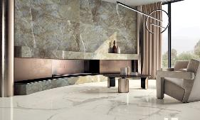
CDE-starlight-statuarioextra-glossy-9mm-patagoniaemerald-glossy-3.5mm-living-002

Starlight is a laminated porcelain stoneware collection inspired by the welcoming allure of marble. It balances restraint with opulence, discretion with luminosity. Advanced decorative technologies achieve remarkable realism through high-definition graphics, precise mineral detailing and rich chromatic depth, producing surfaces of extraordinary authenticity. The collection also introduces a significant technical achievement: large ultra-thin slabs of just 3.5mm, available with the Glossy finish. Starlight is perfectly suited to curved, flowing walls and floors, following their contours without compromise. Light plays across the surface, creating refined reflections that amplify the sense of space and enhance the room’s character.
Starlight Technical Details:
Thicknesses: 3.5 mm, 9 mm
Formats: 60x60, 60x120, 120x120, 120x278 cm
Colours: Carrara White, Statuario Extra, Calacatta Supreme, Versilia Gold, Onyx Pearl, Travertino Class, Dorado Glamour, Patagonia Emerald
Finishes: Glossy, Smooth

Arketipo
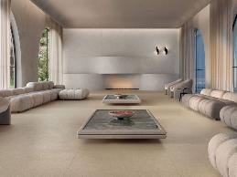
CDE-arketipo-arenasolida-honed-6.5mm-nivessolida-natural-starlight-patagoniaemerald-glossy-3.5mm-lob

Arketipo is an original material designed to rewrite the expressive codes of ceramics. It does not interpret existing models but asserts its own identity: sands, fragments and cement-based binders combine to create surfaces that are rich, deep and intensely tactile.
Thanks to the lightness and flexibility of KERLITE, available in thicknesses of 3.5mm and 6.5mm, the material adapts to curved and sinuous surfaces, giving rise to forms that are essential, continuous and homogeneous. This quality expands the design vocabulary available to architects and designers, opening up endless creative possibilities.
Arketipo Technical Details:
Thicknesses: 3.5 mm, 6.5 mm, 14 mm, 20 mm
Formats: 60x60, 60x120, 90x90, 120x120, 120x278 cm
Colours: Lumen, Arena, Pulvis, Creta, Cotto, Lumen Solida, Arena Solida, Pulvis Solida, Creta Solida, Cotto Solida, Nox Solida, Avio Solida, Silva Solida, Carminio Solida, Helios Solida, Nives Solida
Finishes: Natural (14mm), Honed (14mm), Antislip In&Out, Tough, Natural (KERLITE), Honed (KERLITE)

Advantage

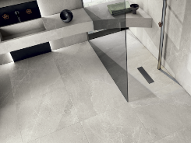
CDE-advantageskin-chalk-naturale-3.5mm-bathroom-002

Advantage reinterprets the stone effect in an entirely new way, harmoniously blending some of nature's most compelling mineral textures. Available in three thicknesses, it is an exceptionally versatile covering: a lightweight, flexible yet extraordinarily resistant ceramic surface suited to countless applications. The balance between material and aesthetics translates into design versatility that extends across volumes, furnishings and curved surfaces, guiding architecture towards distinctive, refined results.
Advantage Technical Details:
Thicknesses: 6.5 mm, 9 mm, 20 mm
Formats: 30x60, 60x60, 60x120, 90x90, 90x180, 120x120, 120x278 cm
Colours: Chalk, Greige, Silver, Graphite
Finishes: Natural, Lapped, Slaty, Grip

Whether in an elegant living area or a sophisticated bathroom, Cotto d'Este delivers the ideal balance of visual beauty, functionality and technological innovation.
Curves are more than a trend — they represent a way of experiencing space, one that can be transformed into a dynamic element, creating a harmonious dialogue between aesthetics, comfort and style.

COTTO D’ESTE - Company PROFILE
Sophistication, quality, and excellence. For over 30 years, Cotto d’Este has been producing high-end porcelain stoneware flooring and cladding, earning a reputation as a global benchmark for architects and designers.
The company’s claim of Exclusive Surfaces translates into intense and textured products, fruit of manufacturing excellence and meticulous attention to detail, capable of preserving the characteristics of artisan craftsmanship and the finest natural material.
Cutting-edge research, exclusive know-how, and constant aesthetic exploration give rise to timelessly beautiful surfaces with a sensory depth like non other. This approach has earned the brand the position of international leader in the industry as well as recognition in the form of numerous prestigious awards. The brand’s pioneering vision has also led to the development of a synergistic and complementary system of technologies, such as KERLITE and 14MM, which push ceramic materials to the peak of technical performance. These are joined by proprietary technological systems, like Safetouch and KERLITE Easy, which further enhance functionality, safety, and creative freedom.
The quality and aesthetic perfection of Cotto d’Este’s surfaces combine with the most important international certifications, with the exclusive Protect® antibacterial technology (which guarantees healthier and safer environments), and with a warranty of up to 20-years on the entire range of products.
Innovation and sustainability guide every stage in the manufacturing cycle, confirming the company’s commitment to a responsible future dedicated to the pursuit of excellence.
Web: www.cottodeste.it
Social: Facebook | Instagram | LinkedIn | Pinterest

PANARIAGROUP - Company PROFILE
Cotto d’Este is part of Panariagroup Industrie Ceramiche S.p.A is part of Panariagroup Industrie Ceramiche S.p.A., an Italian multinational group, world leader in the production and distribution of ceramic surfaces for floor and wall coverings. With over 1,700 employees, more than 10,000 professional clients, and seven production facilities (three in Italy, three in Portugal, and one in the United States), Panariagroup is a key player in its industry, with 80% of its sales concentrated in international markets.
Specialized in the production of porcelain stoneware and laminated porcelain stoneware, the Group offers – through its 9 commercial brands (Panaria Ceramica, Lea Ceramiche, Cotto d’Este, and Maxa (Italian); Margres, Love Tiles, and Gresart (Portuguese); Florida Tile (American); and Bellissimo (Indian) – high-quality and prestigious solutions for every architectural need, whether residential, commercial, or public.
Panariagroup is an international company, present in Italy, Portugal, the United States, India, and over 130 countries worldwide, thanks to a broad and extensive commercial network.

Web: www.panariagroup.it/en/
Social: Facebook |Linkedin |Instagram

Ufficio Stampa / INC - Istituto Nazionale per la Comunicazione
Novella D’Incecco – n.dincecco@inc-comunicazione.it - 338 8538983
Alessandra Dinatolo – a.dinatolo@inc-comunicazione.it - 348 4151778
Nicoletta Fabio – n.fabio@inc-comunicazione.it - 342 623 2637
Valentina Barlacchi – v.barlacchi@inc-comunicazione.it - 342 1475377

